Sanction: | Sanctioned by SwimBC: #
Session Times: | Date – Saturday Jan 7, 2012 |  |  | Date – Sunday Jan 8, 2012
 | Warm-Up:  Start:  Projected Finish: | 2:00pm  3:15pm  8:00pm |  | Warm-Up:  Start:  Projected Finish: | 7:30am  8:45am  12:00pm
Location: | Walnut Grove Community Centre  8889 Walnut Grove Drive, Langley BC  1-604-882-0408  http://bit.ly/YVRtoPool
Pool: | - 8 lane 50 meter tank with bulkhead to create 8 lanes 25 meter for the meet  - Colorado timing system  - Warm-up/warm-down will be available during the meet. Pool will be available Friday, Jan. 06 from 3:00-7:00pm.
Meet Format: | Timed finals
Special Meet Rules: | All Star teams from Pacific Northwest Swimming (PN), Oregon Swimming (OR), Pacific Swimming (PC), Southern California (CA) and Swim BC (BC) will compete with eight girls and eight boys in both the 11-12 and 13-14 age categories.
Scoring | Team Scoring: 9-7-6-5-4-3-2-1  Relay Scoring: 18-14-12-10-8-6-4-2 (One relay from each LSC must score before a second relay from an LSC scores)
Meet Rules: | - All SwimBC and Swimming Canada rules will be in effect  - All swimmers must be registered properly with Swimming Canada/SwimBC, Swimming USA or other FINA-affiliated organization  - Swimming Canada warm-up procedures will be in effect and will be monitored by safety marshals  - Current Swimming Canada / FINA swimsuit rules will be in effect  - Each team is allowed four (4) entries per individual event. Each team is allowed two (2) teams per relay event. Each individual swimmer may compete in up to three (3) individual events plus two (2) relays per day.  - Entry changes will be allowed until the event is called to the blocks.
Entries: | Submit entries in Hy-tek format with the swimmers’ best 25 meter time.
Entry Deadline: | Entries must be received no later than 12:00noon Monday, January 2, 2012.  Send entry files to mikeflegel@swimbc.ca

Hospitality | There will be a hospitality room off the pool deck for coaches, managers and officials.  Snacks and drinks will be provided on deck for swimmers in the meet.
Hotel Information | Sandman Hotel - $94/night + taxes. 60 rooms at Sandman Inn and balance of rooms at Sandman Signature. Breakfast included. I would probably have teams book here.  Contact: Mary Marshall  Address: 8855 202nd St  Langley, BC  V1M 2N9  604 888-7263  1-800-SANDMAN  Holiday Inn Express - $107/night + taxes. 41 rooms including breakfast.  Contact: Mange Sandhu  Address: 8750 204th St  Langley, BC  V1M 2Y5  604 882-2000

Team Lane Assignments:

LANE | INDIVIDUAL EVENTS |  |  | RELAY EVENTS
 | Heat 1 | Heat 2 | Heat 3 | Heat 1 | Heat 2
Lane 1 | - | OR | PC | - | -
Lane 2 | - | PN | OR | OR | OR
Lane 3 | BC | CA | PN | PN | PN
Lane 4 | PC | BC | CA | CA | CA
Lane 5 | PN | OR | PC | PC | PC
Lane 6 | OR | PC | BC | BC | BC
Lane 7 | - | BC | CA | - | -
Lane 8 | - | CA | PN | - | -
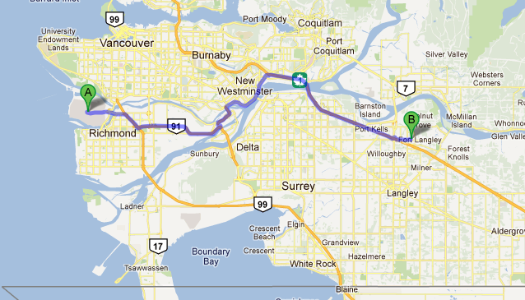
(A) Vancouver International Airport to (B) Walnut Grove Community Centre Pool

 | Event List
 | Saturday Events
Girls Event Number | Event | Boys Event Number
1  3  5  7  9  11  13  15  17  19  21  23  25  27  29  31 | 11-12 200 Free Relay  13-14 200 Free Relay  11-12 100 IM  13-14 200 IM  11-12 100 Freestyle  13-14 100 Freestyle  15 Minute Break  11-12 100 Backstroke  13-14 200 Backstroke  11-12 100 Breaststroke  13-14 200 Breaststroke  11-12 400 Freestyle  13-14 400 Freestyle  15 Minute Break  11-12 50 Fly  13-14 100 Fly  11-12 400 Medley Relay  13-14 400 Medley Relay | 2  4  6  8  10  12  14  16  18  20  22  24  26  28  30  32
 | Sunday Events
Girls Event Number | Event | Boys Event Number
33  35  37  39  41  43  45  47  49  51  53  55  57  59  61  63 | 11-12 200 Medley Relay  13-14 200 Medley Relay  11-12 200 Freestyle  13-14 200 Freestyle  11-12 50 Breast  13-14 100 Breast  15 Minute Break  11-12 100 Butterfly  13-14 200 Butterfly  11-12 50 Backstroke  13-14 100 Backstroke  11-12 200 IM  13-14 400 IM  15 Minute Break  11-12 50 Freestyle  13-14 50 Freestyle  11-12 400 freestyle Relay  13-14 400 Freestyle Relay | 34  36  38  40  42  44  46  48  50  52  54  56  58  60  62  64

